**Name: Sanio Luke Sebastian**

**Roll No: 35**

**Batch: B**

**Date: 12-05-2022**

**NETWORKING & SYSTEM ADMINISTRATION LAB**

**Experiment No.: 11**

**Aim**

Familiarization of Shell Scripting programming.

**Procedure**

1. Write a shell scripting program to find the sum of given digits.

**Code:**

#!/bin/bash

echo "Enter the number : "

read num

sum=0

temp=$num

while [ $temp -gt 0 ]

do

rem=$(($temp%10))

sum=$(($sum+$rem))

temp=$(($temp/10))

done

echo "The sum of the digits of entered numbers is : $sum"

**Output:**

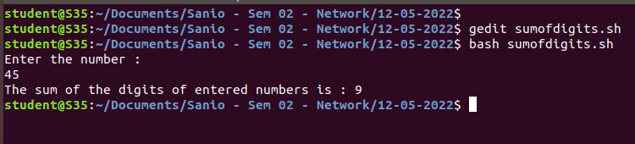

1. Write a shell scripting program to find the average of the given set of numbers using for loop.

**Code:**

#!/bin/bash

echo "Enter the size for no of elements : "

read size

sum=0

echo "Enter the elements : "

for (( i=0; i<size; i++ ))

do

read num

sum=$(($sum+$num))

done

avg=$(($sum/$size))

echo "The average of the entered numbers is : $avg"

**Output:**

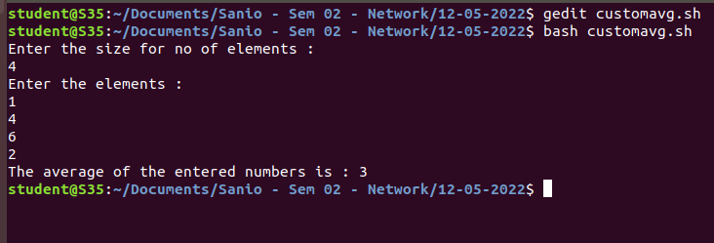

1. Write a shell scripting program to perform a menu driven program for calculator based operations.

**Code:**

#!/bin/bash

loop=1

while [ $loop -eq 1 ]

do

echo "Operations available : "

echo "1. Sum of two numbers."

echo "2. Substraction of two numbers."

echo "3. Multiplication of two numbers."

echo "4. Division of two numbers."

echo "5. Modulus of two numbers."

echo "6. Exit."

echo ""

echo "Enter your choice : "

read choice

echo ""

echo "Enter the number 01 : "

read a

echo ""

echo "Enter the number 02 : "

read b

echo ""

case $choice in

1)

res=`expr $a + $b | bc`

echo "The result of summation of two numbers is : $res"

;;

2)

res=`expr $a - $b | bc`

echo "The result of substraction of two numbers is : $res"

;;

3)

res=`expr $a \* $b | bc`

echo "The result of multiplication of two numbers is : $res"

;;

4)

res=`expr $a / $b | bc`

echo "The result of division of two numbers is : $res"

;;

5)

res=`expr $a % $b | bc`

echo "The result of modulus of two numbers is : $res"

;;

6)

$loop=0

break

;;

esac

echo ""

done

**Output:**

